NYC Citibike Availability Estimation Report
Alexandra Magnusson, Victoria Piroian, and Samantha Taylor

Table of Contents
I. Introduction 2
II. Data Exploration 2
A. Data Preprocessing 2
B. Histogram of Ride Durations 2
C. Ride Duration Summary Statistics 3
D. Conditional Probability of Long Rides Given Membership 3
E. Posterior Probability of Membership for Extended Rides 3
F. Expected Ride Duration by Bike Type 4
G. Bike Type Likelihood for Short Rides 4
III. Discrete Time Markov Chain 4
A. Identifying High-Traffic Stations 4
B. Defining Morning and Evening Blocks for Each Station 5
C. Choosing Between 5- or 10-Minute Time Intervals 6
D. Calculating the Maximum Capacity of Each Station 7
E. Generating the Stationary Distribution 7
F. Results 7
G. Insights 8
IV. Conclusion 8

Introduction
CitiBike is a large component of how people move throughout New York City, especially during rush hour. In this project, we studied CitiBike data in July 2025 to understand how bike availability changes over time at three high-traffic stations. Our goal was to estimate the long-term availability of bikes at each station during the morning and evening hours, or the stationary distributions. The three stations we chose to analyze were W 21St \& 6 Ave, E 33 St \& 1 Ave, and West St \& Chambers St. For each of these stations, we chose two time blocks, in the morning and evening, and for which the number of bikes arriving and departing was tracked at five minute intervals. This supported the construction of a more simplified model of bike usage at each station using Discrete Markov Chains. The approach described in this report allowed us to estimate the long-run behaviour of these stations and helped us understand station specific trends, such as whether the station will be full, empty, or at any other capacity during the morning and evening time blocks. Understanding these patterns can help illustrate how demand, location, and daily commuting patterns can affect bike availability in NYC.

Data Exploration

Data Preprocessing
Before performing any analysis, we performed light preprocessing on the entire dataset to filter out any rides longer than 3 hours (180 minutes) and any rides with negative durations. This data cleaning removed 10,278 rows, reducing the size of the dataset from 4,988,053 to 4,977,775 rows. The rest of the data analysis was performed on this already filtered and cleaned data.

Histogram of Ride Durations
The histogram in Figure X displays the frequency distribution of CitiBike ride durations, in minutes, for July 2025. The distribution is highly right-skewed, meaning a large concentration of rides are at the lower end of the duration scale. The peak frequency, or mode, occurs very early, likely in the 5 to 15 minute range. The frequency of rides decreases rapidly as the duration increases, indicating that long-duration trips are rare. This pattern is typical for ride-share systems, where most trips are short-distance commutes or errands, and only a small fraction of users rent bikes for extended periods.
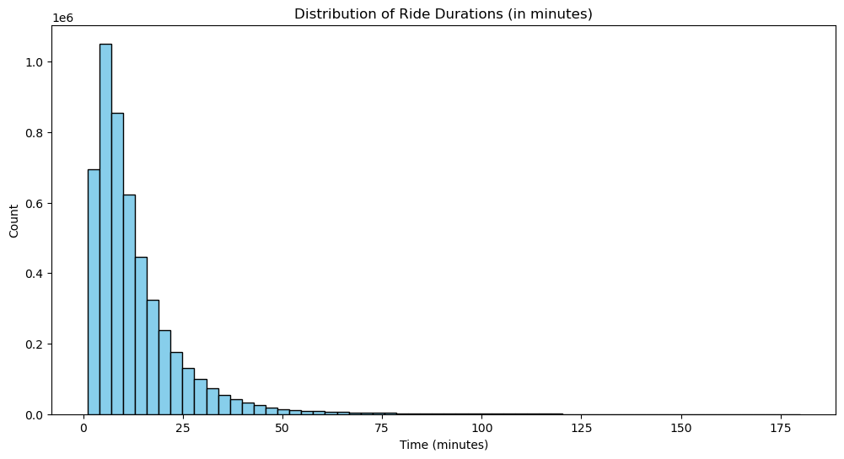

Ride Duration Summary Statistics
The expected ride duration is approximately 13.07 minutes. The variance of the ride duration is 154.20 minutes. This high variance, relative to the mean, is consistent with the right-skewed distribution observed in the histogram in Figure X, where a few long-duration rides pull the average higher and increase the spread of the data. Finally, the probability that a randomly chosen ride will have a duration greater than 20 minutes is 0.1778, or approximately 17.78\%. This confirms that while most rides are short (less than 13.07 minutes on average), nearly one-fifth of the trips extend beyond the 20-minute mark.

Conditional Probability of Long Rides Given Membership
The probability that a ride duration is greater than 20 minutes, given that the user is a CitiBike member, is approximately 0.1440 (or 14.40\%). This value is derived from the fact that out of 3,930,773 total rides taken by members, 566,132 of those rides exceeded 20 minutes. Comparing this conditional probability ($\mathbb{P}(\text{Duration} > 20 \text{min} | \text{Member})$) to the unconditional probability from Question 2 ($\mathbb{P}(\text{Duration} > 20 \text{min}) \approx 0.1778$), the result suggests that CitiBike members are less likely to take long rides (rides over 20 minutes) compared to the overall population of riders (which includes "casual" users). This observation aligns with the expected behavior of members, who typically use the bikes for regular, short-duration commutes, whereas casual users might take longer, leisurely trips.

Posterior Probability of Membership for Extended Rides
The probability that a ride belongs to a CitiBike member, given that the ride duration is more than 25 minutes($\mathbb{P}(\text{Member} | \text{Duration} > 25 \text{min})$), is approximately 0.5991 (or 59.91\%). This is calculated by finding the ratio of member rides exceeding 25 minutes (336,411 rides) to the total number of rides exceeding 25 minutes (561,509 rides). This result is a good illustration of Bayes' Theorem in practice. While the previous question showed that members are less likely to take long rides (a long ride is a negative indicator for being a member), this result shows that, when considering only the set of long rides (over 25 minutes), members still account for nearly 60\% of them. This high proportion suggests that CitiBike members represent a substantial majority of the overall user base, such that even for an atypical event for a member (a long ride), they still make up the largest portion of the population experiencing that event.

Expected Ride Duration by Bike Type
The expected ride duration for an electric bike is approximately 13.28 minutes, while the expected ride duration for a classic bike is approximately 12.55 minutes. The average duration for electric bikes is slightly longer (by about 0.73 minutes) than for classic bikes. This slight difference suggests that electric bikes, with their assisted pedaling, may be favored for slightly longer trips, perhaps because they make covering greater distances or navigating hills easier, encouraging users to extend their journey slightly beyond what they might do with a classic, non-assisted bike.

Bike Type Likelihood for Short Rides
For a ride whose duration is less than 10 minutes (a short ride), the conditional probabilities for the bike types are different. The probability that this ride uses an electric bike ($\mathbb{P}(\text{Electric} | \text{Duration} < 10 \text{min})$) is approximately 0.6870 (or 68.70\%). The probability that this ride uses a classic bike ($\mathbb{P}(\text{Classic} | \text{Duration} < 10 \text{min})$) is approximately 0.3130 (or 31.30\%). The results show a strong preference for electric bikes in short-duration trips (under 10 minutes), as electric bikes account for more than two-thirds of these rides. This is a significant finding given that the average duration for both bike types was similar (Electric: 13.28 min vs. Classic: 12.55 min). This suggests that users often prefer an electric bike even for very short, quick trips, possibly because the ease of acceleration and minimal effort required makes them the default choice, regardless of the trip length.

Discrete Time Markov Chain

Identifying High-Traffic Stations
After the initial preprocessing steps, the data was filtered to show only the rides that took place during Monday to Friday, a total of 3,730,281 of the original 4,977,775 rides (74.9%). The top ten stations were then found by looking at the total activity, which we calculated as the sum of bike arrivals (\texttt{end_station_name} count) and departures (\texttt{start_station_name} count) during each hour of each week day.

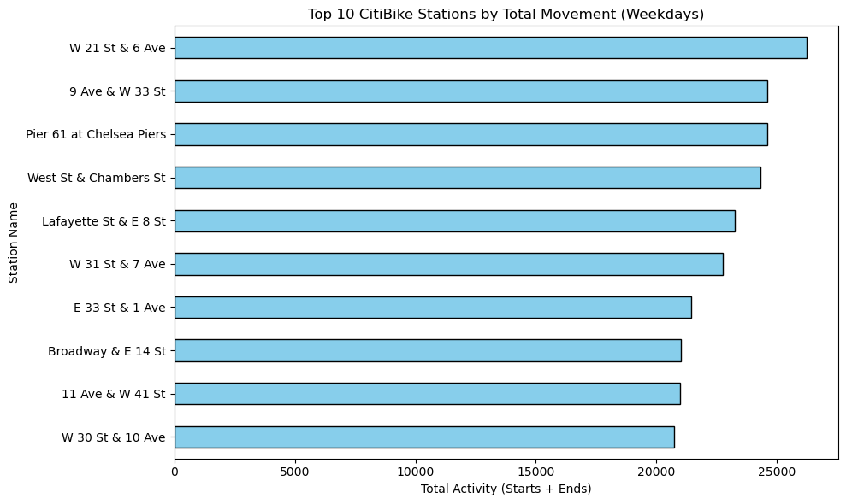

The station at W 21 St \& 6 Ave was the busiest with over 25,000 movements, followed by 9 Ave \& W 33 St and Pier 61 at Chelsea Piers. From this list, we selected three high-activity stations, 1) W 21 St \& 6 Ave, 2) E 33 St \& 1 Ave, and 3) West St \& Chambers St. We chose these stations because they are located in different neighborhoods of the city while still experiencing a high amount of movement to enable the Markov Chain analysis. Our hope was that by selecting stations in different areas of the city, we would see different patterns of behaviour due to various commuter habits.

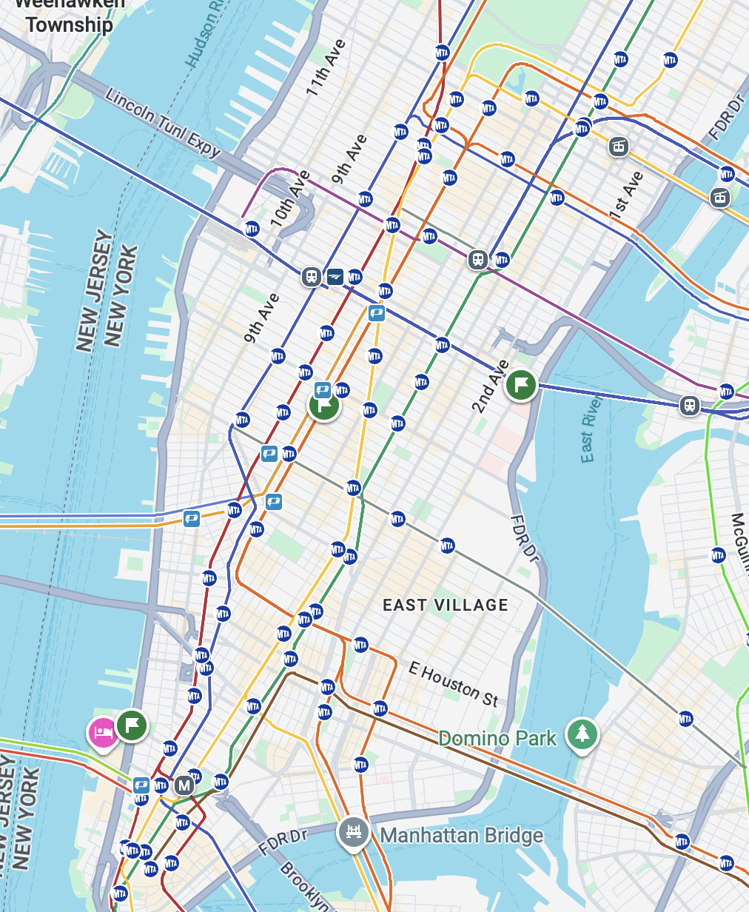

Defining Morning and Evening Blocks for Each Station
After selecting the three stations, we defined a morning and evening block to analyze for the stationary distribution. To identify an appropriate time window for each station, we analyzed the bimodal distribution of the total activity at each station throughout the day, as seen in Figure X. The histograms were made by using the Monday to Friday data for July 2025, where each bar is the sum of the total activity in each hour across all days of the week. The green and red shaded areas represent the morning and evening time blocks respectively, and aim to capture areas of maximum activity and high fluctuation. It was important to define the time blocks specifically for each station because we noticed that the usage patterns differed throughout the day across locations.

\begin{center}
\begin{tabular}{ c | c | c }
Station & Morning Block & Evening Block \\
\hline
W 21 St \& 6 Ave & 7:00 AM - 11:00 AM & 4:00 PM - 8:00 PM \\
E 33 St \& 1 Ave & 6:00 AM - 10:00 AM & 4:00 PM - 8:00 PM \\
West St \& Chambers St & 6:00 AM - 10:00 AM & 5:00 PM - 8:00 PM
\hline
\end{tabular}
\end{center}

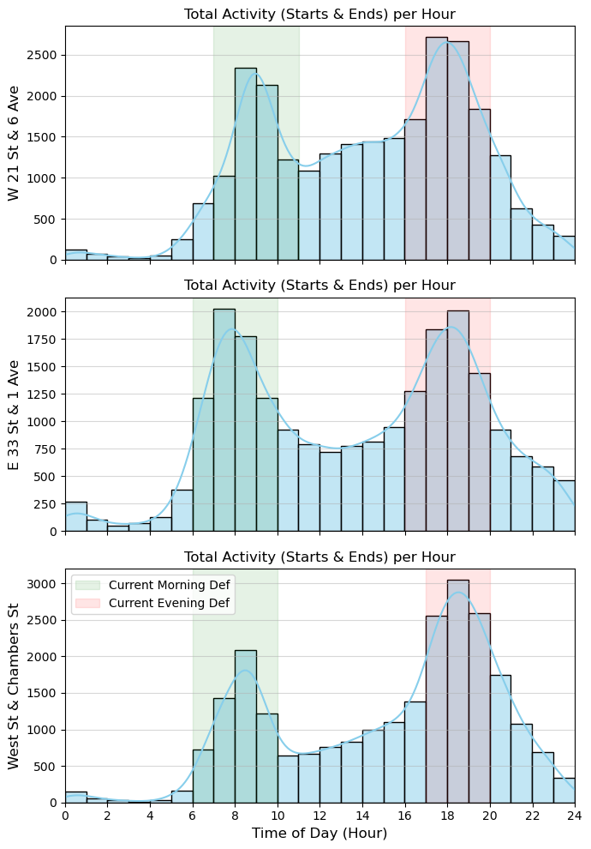

Choosing Between 5 or 10 Minute Time Intervals
To discretize the time blocks for the Markov Chain, whose states are defined as the number of bikes at a station at a certain point in time, we compared 5 minute and 10 minute intervals based on average activity and the frequency of zero activity periods. The overarching idea is to select an interval that balances two competing needs. The first is ensuring the 5 minute interval captures sufficient activity to avoid the model getting "stuck", or too many zero-change time steps, while the second is ensuring the 10 minute interval remains granular enough to prevent excessive, large fluctuations within a single time step. For the 5 minute interval, the average activity including arrivals plus departures across the three stations is approximately 5 events per interval, with a maximum of 23 to 30 events in any single interval. The percentage of intervals with zero activity is nearly identical for both choices, which is around 29\% for the 5 minute interval and around 27\% for the 10 minute interval. Since the 10 minute interval offers negligible improvement in stability, only a $\approx 2\%$ reduction in zero activity periods while doubling the average event count to $\approx$ 9 to 10.5 events, we chose the 5 minute interval. This choice provides a manageable scale for the state-to-state transitions while retaining the granularity needed to capture the high-frequency dynamics of these busy stations.

Calculating the Maximum Capacity of Each Station
We chose the capacity of the stations by looking at the Citi bike map, adding up the number of available bikes and docks to get the total capacity of the station.

\begin{center}
\begin{tabular}{ c | c }
Station & Capacity \\
\hline
W 21 St \& 6 Ave & 64 \\
E 33 St \& 1 Ave & 75 \\
West St \& Chambers St & 82
\hline
\end{tabular}
\end{center}

These capacities were found by adding together the number of Classic Bikes available $+$ the number of Electric Bikes available $+$ the number of open docks available. These capacities are not fixed, as docks can break. We calculated these capacities on November 24th, 2025 at 6:30pm. When revisiting the CitiBike site, these capacities had since changed.

Generating the Stationary Distribution
To find the steady-state stationary distribution for each time block at each station, we created a function which takes the station name, maximum capacity, time block boundaries, a smoothing flag, and the filtered July weekday dataset as input parameters. From these inputs, we first created two time and location-based filters. The first filter identified bike departures, or trips starting at that particular station within the designated time block. The other identified bike arrivals, or trips ending at that station within the time block. We then applied these two filters to the dataset of July weekdays to create two new subsets. Importantly, when we applied the filters we also added a “change” column to each subset with a value of -1 for the departures and +1 for the arrivals. After that, we concatenated the two subsets together, ensuring they were strictly sorted by the exact time of the movement. We then used the resample method from the Pandas library to count the net change in bike inventory by summing the 'change' column over the chosen 5-minute intervals, filling any empty intervals with a zero change, therefore creating a time series of inventory net changes.
This series of changes allowed us to simulate the station's inventory over time during the specified time period. We initialized the inventory at half the station's capacity since we did not have an exact starting capacity for the time period, and then iteratively updated this value at the end of each 5-minute interval by adding the net change. To reflect the physical constraints of the station, the calculated inventory was always clamped between 0 and the station's maximum capacity. This resulting time-series of inventory levels became the state path of the station. Given that many Citi Bike stations often operate within a limited range of inventory levels, potentially leaving many states unvisited, we decided to add a matrix shrinking technique. This involved identifying and sorting only the unique inventory levels that were actually visited during the observation period. However, to be able to know which states were included in the output, we had to create a mapping to link each original visited state (the bike count) to a new, compressed sequential index.
Using this mapping, we constructed a smaller frequency matrix that only included the visited states. We populated this matrix by iterating through the state trajectory and recording the frequency of transitions from one state to the next state, incrementing the corresponding entry in the frequency matrix using the compressed indices.This frequency matrix, which simply records how many times each transition occurred, was then converted into the transition probability matrix. To do this, we focused on each row, which represents a single starting inventory state. For every starting state, we calculated the likelihood of moving to any other state by dividing the number of times that move was observed by the total number of transitions that started from that inventory level. This process effectively converts the raw transition counts into probabilities which must add up to 1 for each starting state. While the function was written to include an option for Laplace Smoothing, which could have been used to artificially ensure every possible transition had a small, non-zero chance of happening, we decided against this. Instead, we chose to rely directly on the empirical data and trust that the sheer volume of our observations gave us the most accurate picture of the station's transition behavior.
Finally, the stationary distribution (π) was calculated by solving the fundamental equation of Markov Chains, π=πP. This is equivalent to finding the left eigenvector of the transition matrix P that corresponds to the eigenvalue of 1. We then used the eig function from the SciPy library to get the corresponding eigenvalues and eigenvectors of the transpose of the transition probability matrix. The resulting eigenvector was then normalized so that its components sum to one, resulting in the long-run probability of the station being in each of the visited inventory states during the defined time block. The final output of this function is the stationary distribution (π) and the index-to-state mapping.

Results
    - W 21 St & 6 Ave
Morning Period of 7:00 - 11:00 AM
State (Bikes): Distribution Probability

53: 0.000418
54: 0.000432
55: 0.001641
56: 0.001939
57: 0.056603
58: 0.003245
59: 0.059671
60: 0.033584
61: 0.009657
62: 0.039308
63: 0.223772
64: 0.569731

Evening Period of 4:00 - 8:00 PM
State (Bikes): Distribution Probability

0: 0.228337  1: 0.126932  2: 0.093658  3: 0.066605  4: 0.008566  5: 0.060627  6: 0.182317  7: 0.123554  8: 0.096087  9: 0.003767  10: 0.002580  11: 0.002180  12: 0.000957 | 13: 0.000554  14: 0.000660  15: 0.000547  16: 0.000520  17: 0.000385  18: 0.000284  19: 0.000187  20: 0.000133  21: 0.000193  22: 0.000100  25: 0.000191  26: 0.000038  28: 0.000038

    - 33 St & 1st Ave
Morning Period of 6:00 - 10:00 AM
State (Bikes): Distribution Probability

0: 0.003845 1: 0.000841  2: 0.001202 3: 0.000601 4: 0.029561 5: 0.000961 6: 0.029801 7: 0.000961 8: 0.029801 9: 0.001081 10: 0.000481 11: 0.001682 12: 0.030041 13: 0.001442 14: 0.029920 | 15: 0.030162 16: 0.032564 17: 0.101544  18: 0.003003  19: 0.003484  20: 0.030360 21: 0.030987 22: 0.031225 23: 0.100534 24: 0.003235 25: 0.002146 26: 0.002277 27: 0.030627 28: 0.002631 29: 0.001547 | 30: 0.002493  31: 0.030342 32: 0.029600 33: 0.029573 34: 0.003434 35: 0.002798 36: 0.002416 37: 0.002258 38: 0.002253 39: 0.028562 40: 0.028531 41: 0.002148 42: 0.116393 43: 0.001511 44: 0.001078 | 45: 0.001400  46: 0.001723 47: 0.001400 48: 0.000969 49: 0.000754 50: 0.000754 51: 0.001508 52: 0.001831 53: 0.000861 55: 0.000969 56: 0.000538 57: 0.000861 58: 0.000215 59: 0.000754 60: 0.001185 | 61: 0.000538 62: 0.000646 63: 0.000969 64: 0.000861 65: 0.000215 66: 0.000754 67: 0.001185 68: 0.000969 69: 0.001723 70: 0.027352 71: 0.002584  72: 0.089701 73: 0.000861 74: 0.000646 75: 0.003338

Evening Period of 4:00 - 8:00 PM
State (Bikes): Distribution Probability

0: 0.147101 1: 0.036751 2: 0.097338 3: 0.105950 4: 0.006922 5: 0.066909 6: 0.006885 7: 0.006733 8: 0.132427 9: 0.131705 10: 0.032151 11: 0.059439 12: 0.002576 13: 0.029859 14: 0.030570 | 15: 0.001676 16: 0.001551 17: 0.000865 18: 0.002115 19: 0.001496 20: 0.001469 21: 0.001354 22: 0.001031 23: 0.001431 24: 0.024184 25: 0.000557 26: 0.000450 27: 0.000350 28: 0.000659 29: 0.001058 | 30: 0.021895 31: 0.000920 32: 0.000624 33: 0.036524 34: 0.000750 35: 0.000612 36: 0.000534 37: 0.000677 38: 0.000521 39: 0.000451 40: 0.000375 41: 0.000225 42: 0.000224 43: 0.000075 45: 0.000075 | 51: 0.000150 52: 0.000075 53: 0.000150 54: 0.000150 55: 0.000150 56: 0.000075 57: 0.000226 58: 0.000075 59: 0.000150 60: 0.000075 63: 0.000226 64: 0.000075 66: 0.000226 67: 0.000150

    - West St & Chambers St
Morning Period of 6:00 - 10:00 AM
State (Bikes): Distribution Probability

61: 0.000048  63: 0.000097  64: 0.000129  65: 0.000126  66: 0.000032  67: 0.000198  68: 0.000468  69: 0.000609  70: 0.000829  71: 0.000902  72: 0.000832 | 73: 0.054577  74: 0.001780  75: 0.002568  76: 0.003494  77: 0.032298  78: 0.155254  79: 0.064179  80: 0.096048  81: 0.348810  82: 0.236722

Evening Period of 5:00 - 8:00 PM
State (Bikes): Distribution Probability

0: 0.091212  1: 0.040259  2: 0.039867  3: 0.153631  4: 0.004680  5: 0.039334  6: 0.104967  7: 0.003295  8: 0.036588  9: 0.070050  10: 0.003390  11: 0.002324  12: 0.002682  13: 0.033362 | 14: 0.033162  15: 0.001597  16: 0.098862  17: 0.096064  18: 0.000917  19: 0.000871  20: 0.000426  21: 0.000582  22: 0.000837  23: 0.000683  24: 0.001286  25: 0.022877  26: 0.000935  27: 0.000504 | 28: 0.000882  29: 0.020414  30: 0.059354  31: 0.000326  32: 0.000314  33: 0.000815  34: 0.015779  35: 0.000292  36: 0.014934  37: 0.000543  38: 0.000517  39: 0.000415  40: 0.000173

Insights
Upon calculating the stationary distribution for each time period, our next step was to contextualize these probabilities by examining the station's traffic flow. We did this by returning to our original hourly graphs, which clearly defined the morning and evening periods, and breaking the event count into departures and arrivals. (Figure X) This visual breakdown helped clarify whether the high traffic observed at the station was predominantly in one direction or involved comparable inflow and outflow.
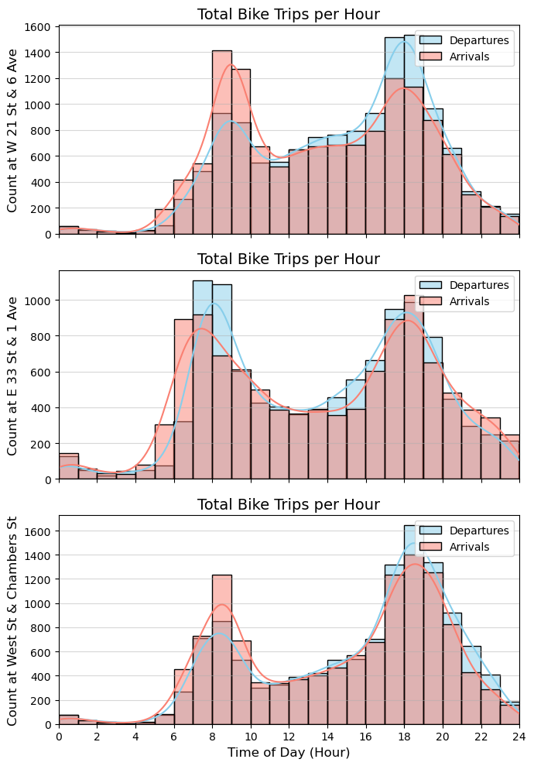

W 21 St & 6th Ave
The stationary distribution for the morning period, from 7:00 to 11:00 AM, revealed a system concentrating heavily at the high end of its inventory. The long-term probabilities are confined to bike states between 53 and 64, showing that the station is nearly always full during this block. Additionally, the stationary distribution predicts a 56.97% probability that the station will be at its maximum capacity of 64 in the long term. This result aligns with the data in the histogram (Figure XX), which clearly shows that the number of arrivals significantly outweighs the number of departures during these hours. Therefore, this station functions as a primary destination hub for commuters, and because the rate of departures is insufficient to keep pace with the influx of arriving bikes, the system is overwhelmingly likely to remain saturated at or near capacity.
On the other hand, the evening hours, 4:00 to 8:00 PM, reveal a reversal of the system's state. The stationary distribution now shows long-term probabilities concentrated heavily at the low end of the inventory, with states ranging from 0 to 28. The greatest risk is depletion, as the highest individual probability is at state 0, with a 22.83% likelihood. This confirms that during the evenings, the station transitions into a major source hub where the rate of departures is significantly greater than the rate of arrivals. Therefore, the long-term probabilities are concentrated toward the station being nearly empty.
In summary, these results provide a consistent and logical picture of a major commuting path. Since W 21 St \& 6 Ave serves as a high-traffic arrival station in the morning, it is expected to be a high-traffic departure station in the evening. The calculated stationary distributions successfully capture this temporal shift, predicting saturation in the morning and a high risk of depletion in the evening.

E 33rd & 1st Ave
The stationary distribution for the morning period, from 6:00 to 10:00 AM, assigns non-zero probabilities to all inventory levels, from state 0 to state 75. This broad distribution, where no single state dominates, indicates the station's inventory is highly volatile and capable of transitioning across almost its entire range in the long run. This finding is supported by the histogram in Figure X. From this data, we can see an initial rush from 6:00 to 7:00 AM where arrivals significantly exceed departures. However, this trend then reverses, with 7:00 to 9:00 AM showing more departures than arrivals. Finally, the traffic balances out in the last hour, from 9:00 to 10:00 AM, with comparable inflow and outflow rates. Because the station quickly switches between acting as a destination hub and a source hub within this four-hour time period, the underlying transition probability matrix captures this effect and results in a stationary distribution that is dispersed across nearly all possible inventory states. The most probable inventory levels are clustered around the mid-to-high capacity range, with state 42 (11.64%), state 17 (10.15%), state 23 (10.05%), and state 72 (8.97%) representing the most frequent inventory counts.
The evening period, 4:00 to 8:00 PM, continues to exhibit this complex, fluctuating behavior. The stationary distribution shows long-term probabilities distributed across inventory states 0 to 67. This spread, though a bit less pronounced than the morning block, still indicates that the station rarely settles into a single, predictable state. To support this, the histogram shows that the station alternates direction within the evening time period. The beginning and end of the evening block, 4:00 to 6:00 PM and 7:00 to 8:00 PM, each have more departures than arrivals. However, from 6:00 to 7:00 PM, there is a distinct peak when arrivals slightly exceed departures. This fluctuation ensures the station is constantly being drained and then partially replenished. Therefore, the long-term probabilities are clustered primarily in the lower inventory range, with the highest single likelihood being state 0 at 14.71%. However, unlike the W 21st station, the system maintains probabilities across a wider range of mid-level states, reflecting its capacity for both quick depletion and modest recovery within the four-hour span.
Overall, the stationary distributions for this location highlight a far more complex system dynamics compared to W 21st St \& 6 Ave, which operated mainly as a pure source or sink. This station's activity suggests it serves as a transfer point or is located near mixed-use areas, as opposed to strictly commercial areas, resulting in less predictable long-term inventory.

West St & Chambers St
During the morning period, 6:00–10:00 AM, the stationary distribution demonstrates an overwhelming tendency toward maximum capacity. The probabilities are tightly clustered at the upper range, from state 61 up to the maximum capacity state of 82. In fact, the three highest probabilities are concentrated at the highest capacity states: state 81 (34.88%), state 82(23.67%), and state 78 (15.53%). Combined, these three states account for over 74% of the long-term probability. This extreme concentration is directly explained by the histogram for this period (Figure XX). From 6:00 AM until 9:00 AM, arrivals significantly exceed departures, making this station a powerful destination sink for early commuters. The long-run state suggests that any bike arriving before 10:00 AM will be contributing to a system that is over three-quarters likely to be almost entirely full.
The evening period, 5:00–8:00 PM, sees the inventory risk swing in the opposite direction. The stationary distribution shows low inventory states, confirming the station's role as a major source hub for commuters leaving the area. However, the risk is distributed unevenly, since the highest individual probability is not state 0, but state 3, with a 15.36% likelihood. This is followed by state 6 (10.50%) and then state 0 (9.12%). The histogram helps explain this by revealing a sharp evening peak with a massive surge of departures between 5:00 PM and 7:00 PM that strongly exceeds arrivals. This high departure rate explains the long-term risk of low inventory. Overall, the stationary distribution for the evening block successfully captures the dual threat of immediate depletion followed by limited, but present, activity at low inventory levels.
As we can see, the station at West St \& Chambers Street presents a distinct profile defined by a high capacity and a highly directional commuter flow, particularly around the World Trade Center/Battery Park City area. Like W 21st St \& 6 Ave, the stationary distribution for this station concentrates heavily at opposite ends of the high-capacity spectrum, indicating reliable, albeit unidirectional, long-term behavior, unlike E 33 St \& 1 Ave.

Conclusion
In this project, we successfully leveraged Discrete Markov Chains to model and predict the long-run stationary distribution of bike availability at three distinct, high-traffic stations across different New York City neighborhoods during peak morning and evening hours. The results demonstrate that the Markov Chain model effectively translated empirical traffic flow data into reliable long-term state assessments. At W 21st St \& 6 Ave and West St \& Chambers Street, the model predicted a clear unidirectional flow. The morning peak showed an extreme likelihood of station saturation due to overwhelming arrivals, while the evening peak predicted a high probability of inventory depletion due to massive departures. Conversely, the analysis of E 33 St \& 1 Ave revealed a more complex, volatile system where rapid switching between source and sink behavior resulted in a stationary distribution spread widely across the entire inventory range, indicating less predictable long-term state stability.
Overall, the calculated stationary distributions provide valuable, actionable insights for Citi Bike management, moving beyond simple traffic counts to quantify the probability of specific failure states of empty or full stations. By quantifying these risks, the results offer a direct, data-driven basis for optimizing bike redistribution efforts and improving service reliability during critical commuting periods.

